COUNCIL ASSESSMENT REPORT
Panel Reference | 2018HCC045
DA Number | DA/2076/2018
LGA | Lake Macquarie City Council
Proposed Development | Place of Public Worship
Street Address | 121 Portland Drive, Cameron Park
Applicant/Owner | The Salvation Army (NSW) Property Trust  C/- ADW Johnson Pty Ltd
Date of DA lodgement | 22 November 2018
Number of Submissions | Four
Recommendation | Approval, subject to conditions of consent
Regional Development Criteria (Schedule 7 of the SEPP (State and Regional Development) 2011 | Private infrastructure and community facilities including Place of Public Worship over $5 million
List of all relevant s4.15(1)(a) matters | - State Environmental Planning Policy (State and Regional Development) 2011  - State Environmental Planning Policy (Infrastructure) 2007  - State Environmental Planning Policy No.44 (Koala Habitat Protection)  - Lake Macquarie Local Environmental Plan 2014  - Lake Macquarie Development Control Plan 2014
List all documents submitted with this report for the Panel’s consideration | - Attachment A: Draft Conditions of Consent  - Attachment B: Amended Architectural Plans  - Attachment C: Amended Landscape Plans  - Attachment D: Amended Engineering Plans  - Attachment E: External agencies responses
Report prepared by | Georgie Williams, Senior Development Planner
Report date | 11 November 2019

Summary of s4.15 matters  Have all recommendations in relation to relevant s4.15 matters been summarised in the Executive Summary of the assessment report? | Yes
Legislative clauses requiring consent authority satisfaction  Have relevant clauses in all applicable environmental planning instruments where the consent authority must be satisfied about a particular matter been listed, and relevant recommendations summarized, in the Executive Summary of the assessment report? | Yes
Clause 4.6 Exceptions to development standards  If a written request for a contravention to a development standard (clause 4.6 of the LEP) has been received, has it been attached to the assessment report? | N/A
Special Infrastructure Contributions  Does the DA require Special Infrastructure Contributions conditions (S7.24)? | No
Conditions  Have draft conditions been provided to the applicant for comment? | Yes

Executive summary
Development Application DA/2076/2018
Proposal: Place of Public Worship
Address: 121 Portland Drive, Cameron Park
Lot 5089 DP 1235166
Applicant: ADW Johnson Pty Ltd
Owner: The Salvation Army (NSW) Property Trust (owner’s consent has been provided)
Lodged: 22 November 2018
Zoning: At the time of lodgement: R2 Low Density Residential and R3 Medium Density Residential
As of 25 January 2019: B4 Mixed use
Integrated Authority: Subsidence Advisory NSW
CIV: $12,284,472
Assessing Officer: Georgie Williams, Senior Development Planner
Recommendation: Approval

Executive summary
This report assesses the proposal against relevant State, Regional and Local Environmental Planning Instruments and Policies, in accordance with Section 4.15(1) of the Environmental Planning and Assessment Act, 1979.
The amended development proposes to construct a three storey place of public worship (POPW) (refer to Figure 1-3 below) with total seating for 560 seats to accommodate the Salvation Army’s Northlakes Corp and Oasis at 121 Portland Drive, Cameron Park. Works include:

Lower ground floor level:

- Lower waiting room;
- Storage / archive;
- Multi-purpose rooms 4, 5, 6 and 7;
- Counsel rooms 5 and 6;
- Accessible shower/WC;
- Toilets; and
- Lift.

Upper ground floor level:

- Main entry courtyard;
- Church – 450 seats;
- Counsel rooms 3 and 4;
- Multi-purpose rooms 1, 2 and 3;
- Upper waiting room;
- Kitchen and servery;
- Play area with storage, disabled WC and lockers;
- Accessible WC;
- Toilets;
- Parents room; and
- Storage.

First floor level:

- Church mezzanine – 110 seats;
- Counsel rooms 1 and 2;
- Meeting rooms 1, 2, 3 and 4;
- Northlake Corp office;
- Oasis office;
- Lunch room;
- Print Room; and
- Lift.

Other facilities:

- Vehicular access from Craighill Crescent (site entry / driveway entrance approved under DA/1250/2018);
- Carparking with 114 car spaces including three disabled car spaces;
- Service area including delivery bay, landscape maintenance room and waste storage area;
- Associated clearing of vegetation, earthworks including construction of retaining walls, stormwater including new easement and landscaping including:

  - Tiered landscape seating to serve as amphitheatre;
  - Pedestrian paths and ramp connecting to Portland Drive;
  - Village green;
  - Landscaping within the carpark;
  - Fencing.

Operational details:

- The facility will operate between the hours of 7am and 10pm, seven days a week;
- The average number of people on site at any one time on Monday to Friday would generally consist of 120 people and 100 vehicles.
- Approximately 200 people will attend Sunday services.
- Attendances greater than 300 people are likely to be associated with special events one or twice a year such as weddings or funerals.
- The Salvation Army’s intention is to not only offer a POPW but to provide a range of associated services including various forms of counselling.
- Weekly operations include:

  - Church administration;
  - Young mums/playgroup;
  - Prayer meetings;
  - Wildfire/youth group;
  - Worship services/church;
  - Connect groups;
  - Homework club;
  - Counselling services;
  - Prayer services/needs;
  - Social needs/case workers;
  - MoneyCare;
  - Education programs;
  - Administration services for OASIS.

- Fortnightly operations include:

  - Men’s group/fellowship;
  - Women’s group/fellowship;
  - Leadership/planning meetings (Corps Council/Census).

- Monthly operations include:

  - Senior citizens group (Prime Timers);
  - Young adults 18+.

- Occasional operations include:

  - Funerals;
  - Weddings;
  - In-house special events for Church;
  - External hire of facility to community groups.

An Operational Plan of Management including a full activity schedule of the above
services, events and community purposes has been submitted with the application.

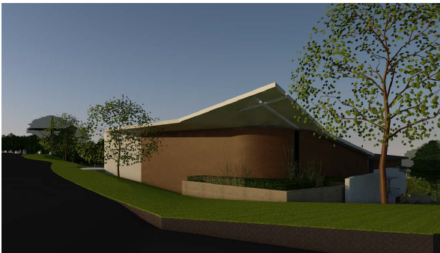
Figure 1 – Photomontage as viewed from the corner of George Booth Drive and Portland Drive (western and southern facade)
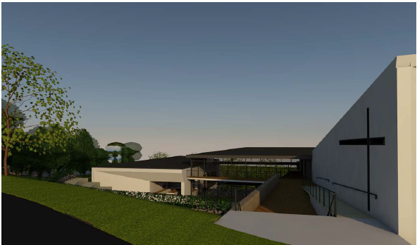
Figure 2 – Photomontage as viewed from Portland Drive (western façade)
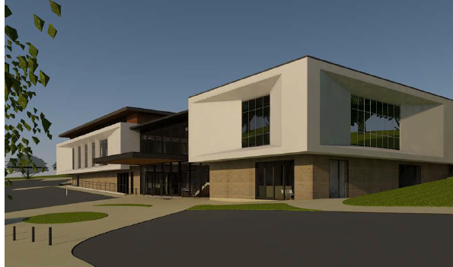
Figure 3 – Photomontage as viewed from driveway / splitter island (eastern façade)

Reasons for determination
The development has been assessed against the matters for consideration that apply to the land to which the development application relates as outlined in Section 4.15 of the Environmental Planning and Assessment Act, 1979 as follows:
- the development meets the requirements of the Lake Macquarie Local Environmental Plan 2014 and other relevant environmental planning instruments;
- consideration has been given to proposed instruments which have been the subject of public consultation;
- the development generally complies with Lake Macquarie Development Control Plan 2014 with any variations to the controls outlined and justified within this assessment report;
- considering the likely impacts of the development on the natural and built environments, the development is considered to provide balanced and appropriate outcomes;
- the suitability of the site for the development, including characteristics and constraints of the land have been considered and it was found the land as being suitable for the development;
- matters of public interest have been taken into account in relation to social, economic and environmental outcomes.

Based on the balance of the matters considered, the development application is recommended for approval. Details of the assessment are contained in the assessment report below.

Community interest

The assessment of the proposed development under Section 4.15(1) of the Environmental Planning and Assessment Act, 1979 has considered the community views. The development application was notified in accordance with the development notification requirements outlined in Section 1.15 of Part 1 of Council’s Development Control Plan 2014 as adopted by Lake Macquarie City Council.

From the initial notification period no submissions were received in relation to the development. However, four late submissions have been received by Council. The matters raised in these submissions were considered as part of the assessment of the development. For detailed comment regarding the matters raised in the submissions refer to Section 4.15(1)(d) of this report.

Site, context and development history

The legal description is Lot 5089 DP 1235166, known as 121 Portland Drive, Cameron Park.

The site is irregular in shape with a total site area of 2.736 hectares and is located on the northern side of George Booth Drive with frontages to Portland Drive to the west, Northridge Drive to the north and Craighill Crescent to the east (refer to Figure 4).

The site is a greenfield site located within the Northlakes Urban Release Area known as Cameron Grove Estate, which was approved under DA/2433/2004. The site is moderately vegetated with a mix of grasses, shrubs and native trees of varying maturity.

A fill batter associated with the construction of Portland Drive has been constructed to the western boundary of the site. The batter is up to nine metres high, and slopes east at approximately 20°. It is noted that the batter along the western boundary is mulched. East of the batter toe, the site slope decreases to about 5° to 10°.

The site is burdened by a drainage easement located along the southern (George Booth Drive) and eastern boundary.

In strategic land use terms, this site falls within an area identified to support the adjoining local centre directly to the west at 309 George Booth Drive, which is currently under construction and will provide a range of facilities for adjoining neighbourhoods, and act as the commercial and social heart of the Cameron Park area.

Access into the Cameron Grove Estate is via a signalised intersection on George Booth Drive into Portland Drive. Direct access into the site from Portland Drive is not achievable due to the existing batter slope. There is no constructed vehicular access into the site.

The site directly adjoins a single storey detached dwelling at 33 Craighill Crescent, which is zoned R2. The eastern side of Craighill Crescent is generally characterised by single storey detached dwelling houses.

The site is strategically located within close proximity to the Pacific Motorway (F1) to the west, Edgeworth and Glendale to the east and Newcastle is approximately 20km to the east.

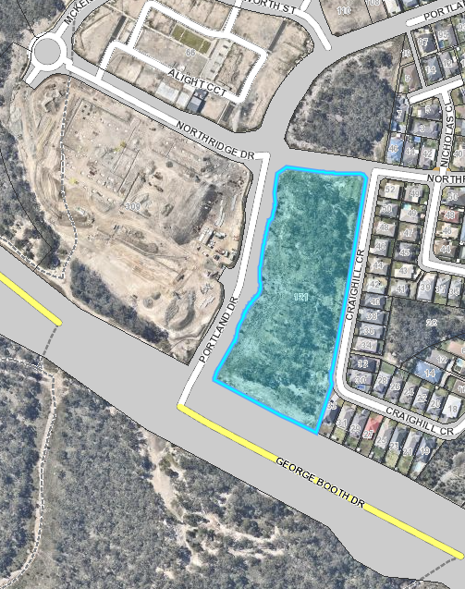
Figure 4 – Locality map of site and surrounding land

PL/84/2018
Pre-lodgement consultation was undertaken with Council on 19 September 2018 for a POPW.
DA/1250/2018
Council approved a Seniors Housing (Residential Aged Care Facility) development on the northern portion of 121 Portland Drive, Cameron Park on 21 December 2018 (refer to Figure 5-7 below).
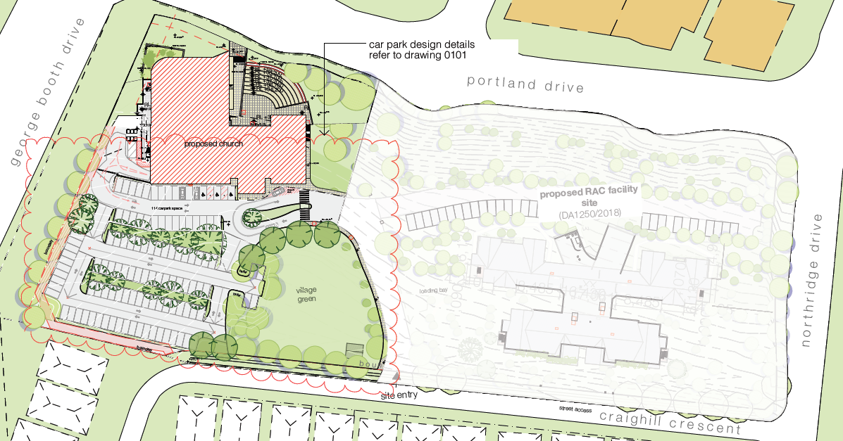
Figure 5 – Site plan showing proposed development and approved Seniors Housing
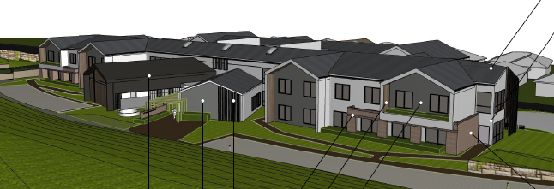
Figure 6 - Street view of approved Seniors Housing from Portland Drive
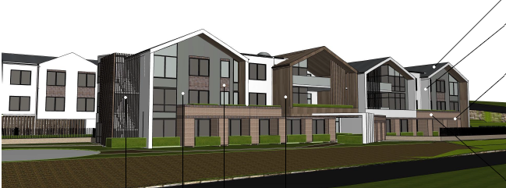
Figure 7 – Street view of approved Seniors Housing from Craighill Crescent
This development will be operated by the Salvation Army’s Aged Care Plus.
The approved development includes a three storey building containing 100 beds for residential aged care and ancillary facilities including:
- Reception;
- Hairdressing and physio rooms;
- Chapel;
- Coffee shop;
- Offices and staff facilities;
- Waste facilities;
- Laundry facilities;
- Kitchen and serveries;
- Dining spaces; and
- Activity rooms.

It is noted 20 beds on the ground floor will cater for seniors with dementia.
The approval also includes site works including earthworks, stormwater infrastructure, vehicular access via Craighill Crescent, car parking and landscaping.
DA/1178/2017
The Hunter and Central Coast Regional Planning Panel approved a local shopping centre to be known as “Cameron Park Plaza” the west of the site at 309 George Booth Drive, Cameron Park on 18 October 2018.
DA/1178/2017/A to DA/1178/2017/E
A number of minor modifications relating to design changes and development contributions have since been considered and approved under Section 4.55(1a) of the Environmental Planning and Assessment Act, 1979.

Detailed Assessment

Environmental Planning and Assessment Act 1979
Applicable State, Regional and Local Environmental Planning Instruments and Policies are detailed hereunder. Where not explicitly detailed, it is considered those instruments or policies are not relevant to the proposal.

Section 4.15: Potential matters for consideration

Section 4.15 (1) (a) (i) the provisions of any EPI’s
State Environmental Planning Policy (State and Regional Development)
In accordance with Schedule 7 (Regionally significant development) Part 5 (Private infrastructure and community facilities over $5 million) of the SEPP, the proposed POPW has a capital investment value over $5 million and is therefore regionally significant development.
The Hunter and Central Coast Regional Planning Panel will determine the development application.
State Environmental Planning Policy (Infrastructure) 2007
Ausgrid
Pursuant to Clause 45(2) of the SEPP Infrastructure, the proposal was referred to Ausgrid for comment. Ausgrid provided their comments on 20 December 2018 as follows:
“Ausgrid requires that due consideration be given to the compatibility of proposed development with existing Ausgrid’s infrastructure, particularly in relation to risks of electrocution, fire risks, Electric & Magnetic Fields (EMFs), noise, visual amenity and other matters that may impact on Ausgrid or the development.”
Subject to approval, a condition is recommended to ensure compliance with Ausgrid requirements.

Development with frontage to classified road

In accordance with Clause 101, developments with frontage to a classified road must not compromise the effective and ongoing operation and function of classified roads, and should be designed to prevent or reduce the potential impact of traffic noise and vehicle emission on the development.

The site has a frontage to George Booth Drive, which is identified as a classified road. As such, Council must not grant consent unless the following objectives are satisfied:

(a) where practicable, vehicular access to the land is provided by a road other than the classified road
Vehicle access is proposed from Craighill Crescent. No vehicle access is proposed from George Booth Drive.
(b) the safety, efficiency, and ongoing operation of the classified road will not be adversely affected by the development as a result of:
(i) the design of the vehicular access to the land
The application provides all manoeuvring on site, thus ensuring vehicles can enter and leave the site is a safe manner. Further, suitable site distances have been provided to ensure the proposed vehicle access to the local network does not have adverse impacts.
- the emission of smoke or dust from the development
The proposed development may have impacts of the emission of smoke or dust during the temporary construction period. To ensure the proposed works do not have adverse impacts, suitable conditions of consent will be imposed.
- the nature, volume or frequency of vehicles using the classified road to gain access to the land
Council’s Traffic Engineer has considered the nature, volume and frequency of vehicles using the classified road to gain access to the site as acceptable. For consideration of this matter, refer to assessment under Part 9 (Specific Land Use), Section 12.8 (Traffic, Parking and Access) in the DCP section of the report.
- the development is of a type that is not sensitive to traffic noise or vehicle emissions, or is appropriately located and designed, or includes measures, to ameliorate potential traffic noise or vehicle emissions within the site of the development arising from the adjacent classified road.
The application proposes a POPW and by virtue of the proposed use is not sensitive to traffic noise or vehicle emissions adjacent to a classified road. For further consideration of this matter, refer to assessment under Part 9 (Specific Land Use), Section 12.7 (Acoustic Privacy) in the DCP 2014 section of the report.
State Environmental Planning Policy No. 44 – Koala Habitat Protection
State Environmental Planning Policy No. 44 – Koala Habitat Protection (SEPP 44) applies to land in the Lake Macquarie Local Government Area.

Schedule 2 of SEPP 44 lists tree species which are considered indicators of potential Koala habitat as they are known to be utilised as feed trees by Koalas. The presence of any of these tree species on a site proposed for development triggers the requirement for an assessment of the study site for ‘Potential Koala Habitat’ (PKH).

PKH is defined in the SEPP as:

“areas of native vegetation where the trees of the types listed in Schedule 2 constitute at least 15% of the total number of trees in the upper or lower strata of the tree component.”

Schedule 2 trees constitute less than 15% of the total number of trees in the upper strata of the tree component on the subject site. As such, the site does not constitute PKH and no further provisions of the policy would apply.

Lake Macquarie Local Environmental Plan (LMLEP) 2014

Clause 1.8A Savings provision relating to development applications

Clause 1.8A LMLEP 2014 stipulates if a development application has been made before the commencement of this Plan in relation to land to which this Plan applies and the application has not been finally determined before that commencement, the application must be determined as if this Plan had not commenced.

At the time of lodgment (22 November 2018), the site was zoned R3 Medium Density with a small portion in the southeast corner zoned R2 Low Density Residential.

LMLEP 2014 (Amendment No.31) came into force on 25 January 2019 rezoning the entire parcel of land to B4 Mixed Use.
The savings provision therefore applies.
Clause 1.9A Suspension of covenants, agreements or instruments
The site is burdened by a drainage easement along the southern and eastern (George Booth Drive) boundaries.

The development includes replacing Council’s existing drainage line with a new drainage line through the carpark. This is due to the proposed location of retaining walls and extensive landscaping adjacent to the existing drainage easement being within the “zone of influence” of this easement.

Council’s Assets Department and Development Engineer support the proposed new location. Appropriate conditions are recommended for imposition (refer to stormwater discussion (Section 2.7) in the DCP section of the report.
Clause 2.3 Zone objectives and Land Use Table
As discussed above, at the time of lodgement, the site was zoned R2 Low Density Residential and R3 Medium Density Residential.
As can be seen in Figure 8 below, the R2 portion relates to a small section in the southeast corner of the site proposed to accommodate landscaping and car parking.
The building is sited entirely over the R3 portion of the site.
A POPW is permitted with consent in the R2 and R3 zone.
The LMLEP 2014 defines a POPW as:
“A building or place used for the purpose of religious worship by a congregation or religious group, whether or not the building or place is also used for counselling, social events, instruction or religious training”.
Other proposed uses are considered ancillary to the dominant function of the site as a POPW, and are therefore permitted with consent.
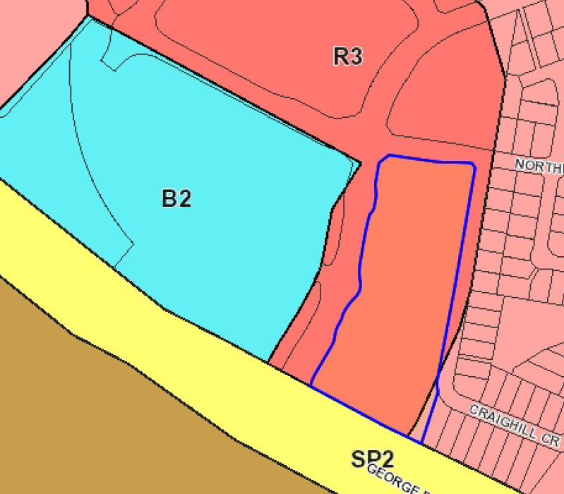
Figure 8 – Zoning map under LMLEP 2014
R2 Low Density Residential
Part of the proposed carpark and landscaping in the southeast corner is zoned R2 and considered ancillary to the POPW. The actual building is sited entirely over the R3 portion of the site.
The R2 objectives are considered as follows:
• To provide for the housing needs of the community within a low density residential environment.
Comment: This objective is not applicable given no housing is proposed. However, the proposed POPW and associated uses will cater for people living in the area.
• To enable other land uses that provide facilities or services to meet the day to day needs of residents.
Comment: The proposed POPW and associated uses will provide a facility and range of associated services to meet the needs of residents in the area.
• To encourage development that is sympathetic to the scenic, aesthetic and cultural heritage qualities of the built and natural environment.
Comment: As detailed in the assessment of the report, the proposed development is considered sympathetic to the scenic, aesthetic and cultural heritage qualities of the built and natural environment.
R3 Medium Density Residential
The majority of the development is sited over the R3 portion of the site including the building, most of the carpark and village green.
The R3 objectives are considered as follows:
• To provide for the housing needs of the community within a medium density residential environment.
• To provide a variety of housing types within a medium density residential environment.
Comment: As discussed above, these objectives are not applicable given no housing is proposed. However, the proposed POPW and associated uses will cater for people living in the area. The proposed use is permissible within the zone.
• To enable other land uses that provide facilities or services to meet the day to day needs of residents.
Comment: The proposed POPW and associated uses will provide a facility and range of associated services to meet the needs of residents in the area.
• To maintain and enhance the residential amenity and character of the surrounding area.
Comment: The R2 interface with the adjoining property to the east requires due consideration. Concern was initially raised regarding the location and height of the retaining wall on this eastern boundary and landscape response. The applicant has amended the scheme to reduce the height of the retaining wall from 2.7m to 0.5m in height and enhance the landscaping by providing a suitable buffer and screening.
Subject to the imposition of conditions of consent, the development is considered to maintain and enhance the residential amenity and character of the surrounding area.

Clause 4.3 Height of buildings
The LMLEP 2014 defines building height as:
“(a) in relation to the height of a building in metres—the vertical distance from ground level (existing) to the highest point of the building, or
(b) in relation to the RL of a building—the vertical distance from the Australian Height Datum to the highest point of the building,
including plant and lift overruns, but excluding communication devices, antennae, satellite dishes, masts, flagpoles, chimneys, flues and the like”.
The R3 portion of the site is subject to a 10m building height limit.
The building is sited over the R3 portion of the site and based on the definition of building height proposes a maximum building height of 10m measured from existing ground level.
Clause 7.2 Earthworks
The western perimeter of the development site has been significantly reshaped as part of the subdivision (DA/2433/2004) to include a fill batter associated with the construction of Portland Drive.
The development includes site earthworks in the order of 3.5m within the building envelope and 1.5m outside of this area (2.1m for largest retaining wall within the car park). A tiered amphitheatre is also proposed outside of the building envelope which will require approximately 3m of cut. All batters are shown as being no steeper than 1:4.
The following has been considered as part of the assessment:

- the likely disruption of, or any detrimental effect on, drainage patterns and soil stability in the locality of the development,
Drainage and soil stability has been considered as acceptable (refer to Stormwater management (Section 2.7) and Geotechnical (Section 2.3) in the DCP section of the report).
- the effect of the development on the likely future use or redevelopment of the land,
The development is expected to have a lifespan of at least fifty years. Any future development is likely to be an intensification of the existing, which may require further earthworks.
- the quality of the fill or the soil to be excavated, or both,
Geotechnical testing has been undertaken. Council’s Erosion and Sediment Control Officer has recommended the imposition of appropriate conditions of consent, which have been included in the draft conditions.
- the effect of the development on the existing and likely amenity of adjoining properties,
The amenity impacts on adjoining properties has been assessed as acceptable. The length of the retaining wall opposite the eastern boundary has been significantly reduced from 2.7m to less than 0.5m. Additional landscaping has also been incorporated between the carpark and this residential property to the east. Any potential impact is now considered to be sufficiently mitigated.
- the source of any fill material and the destination of any excavated material,
Refer to (c) above.

- the likelihood of disturbing relics,
The site is not known to have any likelihood of relics from European occupation.
The land is not mapped as being part of the sensitive Aboriginal cultural landscape.
- the proximity to, and potential for adverse impacts on, any waterway, drinking water catchment or environmentally sensitive area,
The site is not located within the vicinity of a waterway, drinking water catchment or environmentally sensitive area.
- any appropriate measures proposed to avoid, minimise or mitigate the impacts of the development.
Appropriate draft conditions are recommended for imposition to address potential impacts from the proposed earthworks.
Clause 7.21 Essential services
Clause 7.21 of LMLEP 2014 stipulates that consent must not be granted for development unless the consent authority is satisfied adequate arrangements have been made for the provision of essential services.
In this regard, Hunter Water Corporation stamped the plans on 13 November 2018 indicating that water and sewer connection is available.
Electricity supply is available to the development. Furthermore, the application was referred to Ausgrid, who raised no objection to the development.
An amended Stormwater Plan demonstrates suitable stormwater drainage (refer to stormwater discussion (Section 2.7) in the DCP section of the report.
Suitable vehicular access has been provided from Craighill Crescent (refer to assessment under Part 9 (Specific Land Use), Section 12.8 (Traffic, Parking and Access) in the DCP section of the report).

In summary, Council staff are satisfied adequate arrangements have been made for essential infrastructure.

Section 4.15 (1) (a) (ii) the provisions of any draft EPI
At the time of lodgement, the site was subject to a draft amendment to LMLEP 2014 (Amendment No.31) to rezone the site from R3 Medium Density Residential to B4 Mixed Use zone. This amendment was exhibited from 14 October 2013 to 4 November 2013 and came into force on 25 January 2019.
Having regard to the future zone, a POPW is permitted with consent in the B4 zone.
Having regard to the objectives of the B4 zone:
• To provide a mixture of compatible land uses.
Comment: Subject to the imposition of conditions of consent, the development is considered to provide a compatible land use in the B4 zone. The POPW will complement the approved seniors housing development on site and cater for people living and working in the immediate area.
• To integrate suitable business, office, residential, retail and other development in accessible locations so as to maximise public transport patronage and encourage walking and cycling.
Comment: The site is strategically located and will be highly accessible with future public transport (buses) servicing the area. A cycle path adjoins the site.
• To enable development that complements and enhances the core retail function and trading performance of Zone B2 Local Centre and Zone B3 Commercial Core
Comment: The development will complement the retail function and trading performance of the adjoining local centre, Cameron Park Plaza, which is currently under construction.
Furthermore, the application was referred to Council’s Integrated Planning Department who raised no objection to the development.
In regard to building height, the B4 zone has a maximum building height of 13 metres. The development does not exceed 10 metres in height.
It is acknowledged that Part 4 (Development in Business Zones) DCP controls aim to provide active street frontage to Portland Drive, with connectivity to the adjacent local centre. However, this is not feasible in this instance due to the steep batter following the construction of the roadway/subdivision.
The proposed development does provide a pedestrian pathway to Portland Drive that will provide a connection to the adjacent Cameron Park Plaza and bus stop.
The following draft environmental planning instruments are also relevant to this development:
Draft SEPP 44 – Koala Habitat Protection
Amendments to SEPP 44 – Koala Habitat Protection were exhibited from 18 November 2016 to 3 March 2017. The proposed amendments relate to updating definitions of koala habitat, the list of tree species and applicable Council areas as well as the development assessment process. Based on the development site characteristics, the amendments do not have any implications for the proposal.
Draft SEPP Environment
The draft SEPP Environment was exhibited from 31 October 2017 to 31 January 2018. The proposed new SEPP relates to the protection and management of the natural environment, with a particular focus on water catchments, urban bushland and Waterways.
With regard to water catchments, Lake Macquarie City Council is not included in Sydney Water Drinking Catchment and therefore the draft provisions do not apply.
The development site is mapped as part of the ‘Urban Bushland Land Application Map’ under the draft SEPP (note, Lake Macquarie City Council is currently an area to which SEPP 19 applies). The site does not meet the provisions for ‘land zoned or reserved for public open space’ under SEPP 19 nor does it meet the new ‘public bushland’ term under the draft SEPP.
For Waterways, the provisions of the draft SEPP mainly apply to Sydney Harbour and Canal Estates. These provisions have no implications for the proposal based on what it is or do not apply to the Lake Macquarie City Council area.
Draft SEPP Remediation of Land
The draft SEPP Remediation of Land was exhibited from 31 January 2018 to 13 April 2018. The proposed new land remediation SEPP will provide a state-wide planning framework for the remediation of land, maintain the objectives and reinforce those aspects of the existing framework, require planning authorities to consider potential for land to be contaminated when determining development applications, clearly list the remediation works that require development consent and introduce certification and operational requirements for remediation works that can be undertaken without development consent.
A draft instrument is not available for review and therefore the development cannot be assessed against its provisions.

Section 4.15 (1) (a) (iii) DCP’s
Lake Macquarie Development Control Plan (DCP) 2014
Part 3 – Development in Residential Zones
2.1 Site Analysis
Development should demonstrate an understanding of the site and context and provide good site planning, built form and landscaping outcomes. A site analysis plan is required to be submitted to inform the design of the proposed development.
The applicant has submitted a revised Site Analysis Plan, which is considered acceptable for DA purposes.
2.2 Scenic Values
The site is located in Scenic Management Zone 13 – hinterland, high settlement of the Lake Macquarie Scenic Management Guidelines 2013 and the applicant has submitted a Visual Impact Assessment (VIA).
Key design outcomes in this locality that are applicable to the development include:
- Reducing dominance of car parking areas from public areas;
- Provide attractive pedestrian and vehicular through fares;
- Maintaining ridgeline vegetation and other green breaks;
- Use of appropriate materials and colours, and limited signage; and
- Provide tree planting within footpath and front setback areas, and include other appropriate landscaping.

Concern was initially raised regarding the design of the carpark not facilitating good visual outcomes. Accordingly, the design of the carpark has been significantly amended to provide a ‘stepped design’, which has resulted in the height and length of retaining walls being reduced. As part of this design, Council’s existing stormwater easement is to be relocated through the proposed carpark. The proposed landscape plans have also been amended to provide landscaping within the carpark itself, and additional landscaping to the perimeters of the site. It is therefore considered that the amended design now mitigates any potential visual impacts.
The submitted VIA gives an approximate indication of the visual impact of the development and tree removal. The measures outlined to minimise visual amenity in the assessment are supported including ‘visually framing the proposed building by incorporating more perimeter trees of the same species whilst remaining compliant with bushfire controls’.
Council’s Landscape Architect supports the revised design.
2.3 Geotechnical
The site is zoned T3 and T5 (medium to low risk zones) on Council’s geotechnical maps.
A Slope Stability Assessment has been submitted with the application, which identifies that the site in its current condition has a low risk of slope instability. The report notes that excavation into the road batter from Portland Drive will be required and that this may raise the risk of slope instability to moderate. The geotechnical consultant recommends further geotechnical investigation and the provision of engineer designed retaining walls.
Council’s Development Engineer supports the report and has recommended conditions of consent to ensure the recommendations of the report are implemented.
2.4 Mine Subsidence
The site is located within a mine subsidence district.
Accordingly, the applicant sought and obtained the approval of Subsidence Advisory NSW (SA NSW) prior to lodgement of the application. SA NSW provided their General Terms of Approval on 20 December 2018, which will be included on any consent issued.
2.7 Stormwater Management
As previously discussed, the site is burdened by a drainage easement along the southern and eastern (George Booth Drive) boundaries.
The development includes replacing Council’s existing drainage line with a new drainage line through the carpark.

This is due to the proposed location of retaining walls and extensive landscaping adjacent to the existing drainage easement being within the “zone of influence” of this existing infrastructure.
Council’s Assets Department and Development Engineer have reviewed the revised stormwater plan and revised location of the drainage easement as acceptable and have recommended conditions of consent to ensure the proposed outcomes are implemented.
2.11 Bushfire
The site is mapped as bushfire prone land – Vegetation Category 2 and Vegetation Buffer.
The proposed use is not captured under special fire protection purpose and does not include a subdivision. However, given the bushfire mapping of land to the south of George Booth Drive, which is within 100m of the site, as “Vegetation Category 1”, the application was referred to NSW Rural Fire Service (RFS) as an advisory. Figure 9 below illustrates the location of potential fire hazards near the proposed development and relevant Asset Protection Zones (APZ).
The site slopes down-hill in an easterly direction, and slightly uphill in a southerly / south westerly direction. Hazard vegetation identified to the east is downslope, resulting in a ‘>0 – 5 degree’ downslope class determination. The “Forest” Vegetation to the south is only very slightly upslope of the development.
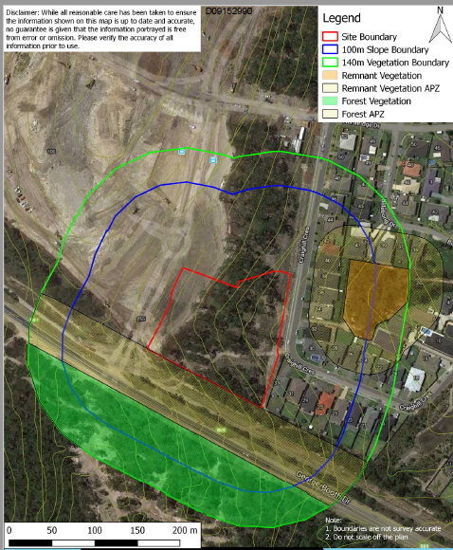
Figure 9 – Location of potential fire hazards near the proposed development and relevant APZs
The NSW RFS have reviewed the submitted Bushfire Report and recommended the imposition of conditions, which will be included on any consent issued.
2.12 Flora and Fauna and 2.13 Preservation of Trees and Vegetation
It should be noted the development application was lodged with Council prior to the Biodiversity Conservation Act 2016 coming into force in Lake Macquarie on 24 November 2018.
It is important to note that under DA/1250/2018, approval has been granted to remove approximately 0.6 ha of native vegetation including five hollow-bearing trees within the northern portion of the site. This vegetation community is not listed as threatened and is severed from connectivity to the north, east and west.
The extent of proposed earthworks results in clearing the majority of native vegetation onsite (approximately 1.1 ha).
Native vegetation at the site is mapped as coastal plains stringybark - apple forest. This vegetation community is not a threatened species.
Council’s Ecologist has reviewed the development and submitted Ecological Assessment Report and advised the following:
Threatened Species
The site potentially provides habitat to a number of threatened species as part of a wider area of occupation (see Table 1).

Table 1 – Summary of threatened species with potential to occur on site
Level of Occurrence | Species
Threatened species considered to potentially occur within the study area | - Squirrel Glider (Petaurus norfolcensis), Grey- Headed Flying-Fox (Pteropus poliocephalus);  - Masked Owl (Tyto novaehollandiae), Powerful Owl (Ninox strenua), Little Lorikeet (Glossopsitta pusilla), Varied Sittella (Daphoenositta chrysoptera;  - Greater Broad-nosed Bat (Scoteanax rueppellii), Eastern False Pipistrelle (Falsistrellus tasmaniensis), East Coast Freetail bat (Mormopterus norfolkensis), Little Bentwing-bat (Miniopterus australis) and Eastern Bentwing-bat (Miniopterus schreibersii oceanensis), Yellow-bellied Sheathtail-bat (Saccolaimus flaviventris);  - Tetratheca juncea, Grevillea parviflora subsp praviflora (note: targeted surveys for these species during the peak flowering period did not record them onsite).

Significant Habitat Features
There are a number of significant habitat features on the subject site (see Table 2).
Table 2 – Summary of significant habitat features on site
Habitat Feature | Site Attribute
Foraging habitat | The site contains potential foraging habitat for native birds, bats, reptiles and arboreal mammals as part of a wider area of occupation.
Habitat Hollows | Five hollow-bearing trees (12 small, two medium and one large) were identified across the subject site.
Corridors | Native vegetation at the site forms part of a corridor in Council’s Native Vegetation and Corridor Map v 1(2011), however recent development has severed connectivity to the north, east and west. There is an approximately 80 m gap separating the site from native vegetation south of George Booth Drive.
Riparian Habitat | No watercourses or riparian habitat occur.

Flora and Fauna Survey Effort
The submitted Ecological Assessment generally complies with survey requirements in Council’s Flora and Fauna Survey Guidelines, and included targeted surveys for Tetratheca juncea and Grevillea parviflora subsp praviflora during the peak flowering period. These species were not recorded onsite.
A reasonably high density of hollows occur onsite; an additional night spotlighting and stagwatching was conducted under DA/1250/2018 to meet minimum survey requirements, where eastern bentwing-bat Miniopterus schreibersii oceanensis, listed as vulnerable on the TSC Act, was recorded onsite.
Council’s Ecologist is satisfied with the proposal and confirmed the development is unlikely to result in a significant impact to threated species, communities or their habitat. A species impact statement is not required.
With respect to koala habitat, refer to SEPP 44 discussion.
2.17 Social Impact
The applicant has provided a social impact assessment within the submitted Statement of Environmental Effects (SOEE). Council’s Social Planner has reviewed this information as acceptable noting the POPW and associated support activities will have an overall positive social impact.
The intention for the facility to not only offer a POPW, but to also establish the venue as a valuable part of the local community, will provide assistance to the local community who are in need of a range of services. These services are intended to include playgroups, youth groups, homework club, counselling services, education programs, and financial counselling services. In addition, the facility will be a venue for private hirers such as ballet/dance groups, drama/theatre groups, and schools.
Any potential negative social impacts associated with the proposal are likely to be those that relate to traffic and noise issues, which are discussed under Part 9 (Specific Land Use), Section 12.7 (Acoustic Privacy) and Section 12.8 (Traffic, Parking and Access).
2.18 Economic Impact
The application proposes a permitted form of development for the zone, and thus provides an expected development outcome. Whilst the value of the development exceeds $5 million, it is considered an economic impact assessment is not necessary in this instance.
2.19 Lot Amalgamation in the R3 Zone
The site represents a single R3 zoned allotment. As demonstrated in Figure 1, there are no immediately adjoining R3 zoned allotments and thus the proposal would not result in the isolation of any lots.
2.20 Utilities
The development will provide appropriate utility infrastructure; refer to Clause 7.21 (Essential services) in the LEP section of the report.
The submitted roof plan does not show any plant, equipment or lift overrun. A suitable condition is therefore recommended for imposition to ensure any plant and equipment is adequately screened.

3.1 Streetscape
The overall site has frontages to George Booth Drive, Portland Drive, Northridge Drive and Craighill Crescent. Presentation to the streetscape is therefore critical particularly the highly prominent corner at the intersection of George Booth Drive and Portland Drive (refer to Figure 10-12 below). The architect has made a design statement with the architectural roof feature and façade treatment.

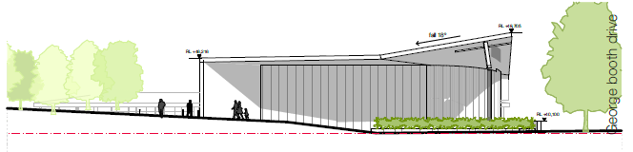
Figure 10 – Streetscape view from Portland Drive

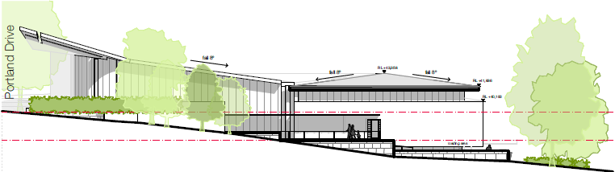
Figure 11 – Streetscape view from George Booth Drive (Note: This plan has not been updated to show the additional landscaping along the George Booth Drive boundary)
Figure 12 – Photomontage as viewed from the corner of George Booth Drive and Portland Drive (western and southern facade)
Following a preliminary assessment, concern was raised regarding the design of the carpark area being constrained by a stormwater easement, retaining walls and landscape areas reduced to remnant proportions. Particular concern was raised regarding:
- The streetscape/visual impact on George Booth Drive;
- The location of retaining and a raised rain garden on Craighill Crescent; and
- Tree planting within the carpark area inadequate to support trees within a hardstand area.

Accordingly, the applicant has amended the scheme to relocate the drainage easement internally within the carpark area, which results in a designated planting area along the southern and eastern perimeter that can support tree planting achieving visual mitigation of the building and carpark within the residential neighbourhood. Proposed street trees will also make a positive contribution to the streetscape.
Having regard to the objectives of the streetscape control, it is acknowledged that a building which has a better relationship / activation of the Portland Drive streetscape is preferred however this is not feasible due to the existing steep batter following the construction of the roadway/subdivision. The applicant has also minimised window openings on the western elevation due to the harsh western orientation. However, the design has achieved direct and legible pedestrian access to the main entries of the building via pedestrian pathways from Portland Drive, Craighill Crescent and the proposed carpark.
It is also important to note the proposed church first floor level (RL 38.90) sits well below an average RL of Portland Drive to the west of RL 42.00. The pitched roof enables the church to open up to the main intersection and also ties the building into the existing steep slope. The location of the tiered open amphitheatre, although sunken below street level, will provide a level of activation and activity.

Loading dock and service areas have been successfully integrated into the building and are not immediately visible to the surrounding streets given the topography of the site and proposed landscape response.

The building provides variation in materials and colours to provide visual interest (refer to external finishes schedule).

The amended landscape design is supported by Council’s Landscape Architect and the architectural design is considered to complement the approved seniors housing development on site and desired future character of the area.

3.2 Street Setback
The street setback control states that where there are existing adjoining residential buildings within 40 metres, the front setback must be consistent with the established setbacks.
With the exception of 33 Craighill Crescent, the site has no immediate adjoining neighbours.
A consistent setback of 5m for No.33 and the dwelling houses on the opposite (eastern) side of Craighill Crescent applies. However, it is considered this site should be treated as a stand-alone site given the site’s orientation, location with multiple street frontages and future B4 zoning.
The building has been sited with a setback of approximately of 72m from Craighill Crescent. The location of the carpark has been setback approximately 4.5m from the adjoining neighbour. The proposed setbacks from Craighill Crescent are considered sufficient and ensure the bulk and scale of the building (when viewed from the street) is minimised.
A minimum setback of 3.5m is proposed to Portland Drive. This setback is a consequence of the existing batter levels within this portion of the site. No objection is raised to the setback.
A minimum setback of 7m is proposed to George Booth Drive, which is considered acceptable.
3.3 Side Setback
Due to the site’s orientation and location with multiple street frontages, side setbacks are not applicable.
3.4 Rear Setback
Due to the site’s orientation and location with multiple street frontages, rear setbacks are not applicable.

3.5 Site Coverage
The maximum site coverage must not exceed 50% of the site.
Based on the definition of site coverage, the proposed site coverage equates to 18% of the site area.
3.6 Building Bulk
The building bulk is appropriate for the site and the development type. Refer to Part 9 (Specific Land Use), Section 12.4 (Building form and character) discussion below.
3.8 Roofs
The roof design is considered acceptable (refer to Section 2.20 (Utilities) and Section 3.1 (Streetscape) for discussion.
3.9 Views
No significant views within the surrounding locality will be impacted upon by the proposed development.
3.10 Solar Access and Orientation
The applicant has submitted shadow diagrams for mid-winter and the equinoxes between 9am and 3pm, which indicates no overshadowing to adjoining properties. No concern is raised.
3.11 Energy Efficiency and Generation
BASIX is not applicable. However, the development will be required to comply with Section J of the NCC whereby energy efficiency requirements apply.
4 Visual Privacy and 4.1 Acoustic Privacy
The development provides for appropriate visual and acoustic privacy, refer to Part 9 (Specific Land Use), Section 12.6 (Visual Privacy) and Part 9 (Specific Land Use), Section 12.7 (Acoustic Privacy) discussion.
4.2 Landscape Area and 4.3 Landscape Design
The landscape design is well developed and assists with integrating the development into the site, refer to Part 9 (Specific Land Use), Section 12.5 (Landscaped Area) discussion.
4.5 Front fences and 4.6 Side and rear fences
The site will be secured through perimeter palisade metal fencing on the Portland Drive boundary and extending this fence to the building setback line along the southern boundary. From this point southwards, a timber lapped and capped fence is proposed, in keeping with fencing along the residential boundary with the George Both Drive corridor. The site is to remain open from the shared driveway with the approved seniors housing development at Craighill Crescent to the adjacent residence in the south-eastern corner of the site.

The fencing is considered appropriate and acceptable as it will assist in clearly defining the site ownership and maintenance, whilst ensuring appropriate visual outcomes. Council’s Landscape Architect supports the fencing design.

4.7 Traffic and Transport, 4.8 Design of Parking and Service Areas and 4.9 Design of Driveways

The development does not constitute traffic generating development. The amended design of the car park, service areas and driveway has achieved compliance with DCP 2014 and relevant Australian Standards. Refer to Part 9 (Specific Land Use), Section 12.8 (Traffic, Parking and Access) discussion.

4.11 Car Parking Rates

Table 7 (Car Parking Rates for Development in Residential Zones) stipulates a POPW is required to provide one space per 3 seats.
The ground floor plan identifies 450 seats whilst the mezzanine level identifies 110 seats resulting in a total of 560 seats.
Based on the above rate, the development is required to provide 187 car spaces.
The development caters for 114 car spaces resulting in a shortfall of 73 car spaces, DCP 2014, which stipulates that a reduction to the car parking rate must not exceed 20% or 20 spaces, whichever is the lesser.
The applicant has sought to justify the deviation as follows:
“peak congregation attendance is only likely to be 300 people in the future, and is currently
only 200. The 114 spaces would allow a congregation capacity of 342 spaces, which is
well in excess of current peak congregation numbers, while still supplying sufficient onsite parking to cater for the parking demand generated mid-week with the administration, counselling and educational services provided by the Church.

Use of the full capacity for the church is only expected once or twice a year at worst
with private hire of the church or use of the church for major regional and state events. It is proposed that for events with a likely attendance in excess of 340 persons, an event
specific Traffic Management Plan will be implemented which focuses on use of mini or charter buses to convey people to and from the site using off-site parking areas available at other local churches, public parking areas, accommodation facilities and/or public transport
interchanges/facilities. In this regard, the Salvation Army already owns and operates a minibus (16-seater) to transport members of the church to Sunday Worship as well as various events and functions around the area and state.

It is therefore concluded the proposed place of worship provides sufficient onsite
carparking to cater for up to 99% of events or uses of the church during the year and
that for the other 1% of use an event specific TMP can be implemented to mitigate the onsite parking and traffic issues related to the major attendance event”.

Council’s Traffic Engineer has reviewed the submitted Traffic Impact Assessment and Operational Management Plan and recommended that given the shortfall in car parking an event specific Traffic Management Plan be prepared prior to determination, showing alternative arrangements to be put in place when larger events are scheduled, and any agreements that have been made with other nearby parking providers to cover this shortfall.
An area for a future additional carpark should be nominated should the congregation grow to a regular attendance of more than 342 people – noting that the likelihood of growth is high as Cameron Park is a growing area that is currently not well provided with other church facilities or local congregations.
In response to Council’s request for additional information, the applicant has suggested that a condition of consent be imposed limiting the capacity of the POPW to a maximum of 342 people at any one time. Council’s Traffic Engineer has no objection to this condition with the understanding that a modification to the development application or new development application will be required if the applicant intends to increase the capacity.
Accordingly, a condition of consent is recommended for imposition to limit the maximum number of people to 342 people at any one time. However, concern is raised whether a condition of this nature is practical and enforceable given the total seating capacity of the auditorium. It is therefore the recommendation of this report that no seating is approved in the mezzanine level.
A condition of consent is also recommended for imposition to ensure the village green is not utilised for over flow car parking. This is due to maintenance, landscaping and engineering concerns.
If the congregation does grow to exceed 342 in the future, the applicant could explore options to formalise car parking in the village green area. This would require a Section 4.55 application or new development application to modify seating and car parking numbers.
4.12 Non-discriminatory Access
An Access Report has been submitted with the application. The report identifies all requirements of the applicable Australian Standards are achievable with the development and specific details can be resolved at Construction Certificate stage.
Council’s Ageing and Disability Services Officer has reviewed the report as acceptable and accordingly a condition is recommended for imposition to ensure the recommendations shall be incorporated into the design and construction of the development.
The development has catered for three disabled car spaces in accordance with the DCP rate of one space per 50 car spaces.
4.13 Safety and Security
Development should contribute to the liveability and safety of users and be designed to limit opportunities for crime. A Crime Prevention Through Environmental Design (CPTED) report is required to be submitted for a POPW.
Accordingly, the applicant has submitted a CPTED report, which identifies and addresses areas of crime risk associated with the development. The report identifies a number of strategies to mitigate risk and to ensure that the proposed development is designed / constructed in accordance with CPTED principles.
Council’s Community Planner for Youth and Safer Communities has reviewed the report and supports the recommendations contained within the report regarding surveillance, access control, territorial reinforcement, activity and space management, building design, lighting, access, car parking, fencing, landscaping. A condition is recommended for imposition to ensure the recommendations are implemented.
The application was also referred to the NSW Police for comment. No comment was received during the assessment of the application.
4.14 Cut and Fill
Development should minimise the extent of earthworks, stormwater infrastructure and retaining structures and associated costs.
Cut and fill should only occur within building and car parking footprints and be in accordance with Figure 13 below:
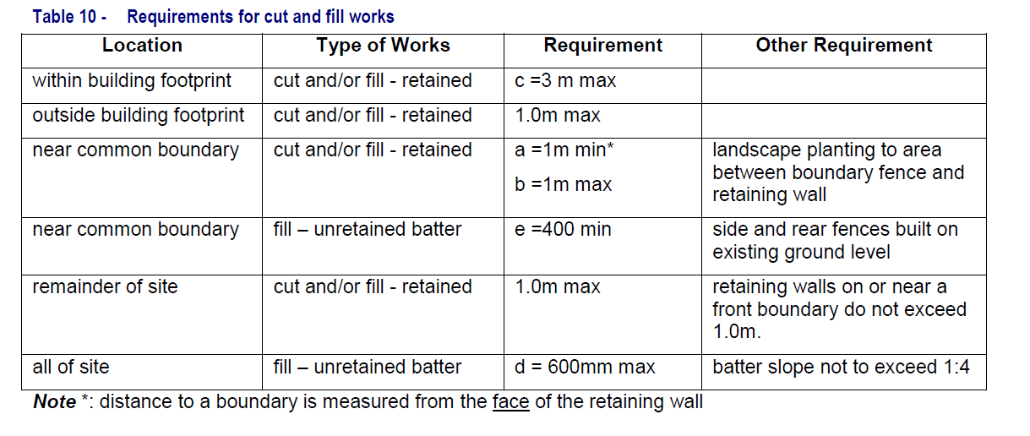Figure 13 – Requirements for cut and fill works
As detailed elsewhere in this report, an existing fill batter associated with the construction of the Portland Drive roadway has been constructed. This batter slopes down from the western boundary of the site to the eastern boundary and has presented major design challenges for this development and the approved Senior Housing development.
The development includes site earthworks in the order of 3.5m within the building envelope and 1.5m outside of this area (2.1m for largest retaining wall within the car park). A tiered amphitheatre is also proposed outside of the building envelope which will require approximately 3m of cut. All batters are shown as being no steeper than 1:4.
Whilst the proposed earthworks do not strictly comply with Council’s numerical provisions, it is considered the earthworks are acceptable in this instance. The majority of earthworks required is a consequence of the roadway batter, which does not reflect previous natural contours. Due to the existing site levels, the development of the site in accordance with the zone objectives would result in earthworks that could not strictly comply with the numerical controls.
The proposed earthworks have been appropriately internalised within the site to ensure impacts to surrounding lands do not occur. Further, any retaining walls have been stepped and landscaped to reduce any visual impact of the structures.
The length of the retaining wall opposite the eastern boundary has been significantly reduced
from 2.5m to less than 0.5m. Additional landscaping has also been incorporated between the carpark and this residential property to the east. Any potential impact is now considered to be sufficiently mitigated.

Council’s Engineer has assessed the revised earthworks as acceptable.
5.1 Demolition and Construction Waste Management
The application proposes construction works and building waste will be generated.
The applicant has submitted a revised Waste Management Plan to the satisfaction of Council’s Waste Officer. A suitable condition of consent will be imposed to ensure the requirements of the Waste Management Plan shall be implemented during the clearing, excavation and construction of the development.

5.2 Waste Management
The proposed POPW comprises two major components being the “office/administrative” component and the “Religious/Social” component. Operational waste for the proposed
development has been calculated for each of these components based on the waste generation rates requiring a total of six x 1,100L bins per week with three for general waste, two for green waste and one for recycling.

Council’s Waste Officer has advised that based on the anticipated volumes of waste, there appears to be sufficient storage.
The amended architectural plans have identified a suitable garbage storage/collection area for the bins which will be serviced by a private waste contractor. Bins will be collected directly adjacent to the waste storage area. Turning paths for the service area have been provided and assessed by Council’s Development Engineer as acceptable.

Council’s Waste Officer has reviewed the proposed development and advised the waste vehicle access route is shown as accessible by Council’s fleet (for 1100 litre bins collected by rear lift waste collection vehicles, this is vehicle length 8m, as per Table 27 of the new Waste Management Guidelines Appendix 2), therefore Council (or private waste services) could collect the bins. Appropriate conditions of consent are recommended for imposition regarding waste management.

5.5 Erosion and Sediment Control
Development should prevent erosion and sediment laden run off during site preparation, construction and ongoing use of land. Appropriate erosion and sediment control plans are required to be submitted with development applications. Measures to mitigate impacts must be incorporated into development.
Erosion and sediment control plans have been submitted with the application, which Council’s Erosion and Sediment Control Officer has reviewed as acceptable subject to the imposition of appropriate conditions of consent.
5.7 Noise and Vibration
Development should minimise generation of noise and/or vibration impacts. Construction of development should comply with relevant environmental noise standards.
To ensure the construction of the development occurs within relevant environmental standards, suitable conditions of consent will be imposed. The applicant will also be required to prepare a Construction Management Plan to ensure appropriate measures have been considered for site access, storage and the operation of the site during all phases of the construction process in a manner that respects adjoining owner’s property rights and residential amenity in the locality, without unreasonable inconvenience to the community.
Part 9 (Specific Land Uses) – Section 12 (Place of Public Worship)
12.1 Introduction
A large-scale place of public worship means a place of public worship with a seating capacity of 100 people or more in the assembly area and which services people who live outside the neighbourhood where the place of public worship is located.
Assembly Area means the sum of that portion of the gross floor area of a building that is to be used for public assembly, for the purpose of worship or other purposes. It includes any secondary areas of assembly, such as choir or musician’s areas, altar areas, confessional areas, podiums, or rooms capable of being used for overspill accommodation of the congregation during a worship service. Ancillary areas such as kitchens, toilets, offices, washrooms and accommodation, which are not normally used for worship, are not included in the calculation of the assembly area.
12.2 Aims of POPW
The key aims are:

1. To ensure the size, scale, height, form and external appearance of a place of public worship is compatible with the prevailing and desired character of the locality.

Comment: The development is considered consistent with the desired future character to rezone the subject site from R3 to B4. The B4 zone will provide support, complement and enhance the core retail function and trading performance of the adjoining B2 Local Centre.

In terms of height, the development complies with the statutory height control of 10m. The size, scale and architectural style is considered complementary to the approved three storey seniors housing development on the northern portion of the site and the approved shopping centre directly to the west, which is currently under construction.

The external appearance of the development is considered acceptable and provides an architectural statement on a prominent corner site. The building provides variation in materials and colours to provide visual interest.

2. To maintain the streetscape character and amenity of the surrounding locality, especially in residential neighbourhoods.
Comment: Streetscape character has been adequately discussed under Section 3.1 (Streetscape) of the report. Residential amenity is discussed in detail below under Section 12.6 (Visual Privacy) and Section 12.7 (Acoustic Privacy).

3. To encourage the location of large-scale places of public worship on lands zoned for business, industrial or recreation purposes.
Comment: Given the seating numbers (560 seats), the proposed development constitutes a large scale POPW. As detailed under draft instruments, the future B4 zoning is consistent with this control. Given the shortfall in car parking, seating numbers will be limited to 342 seats.

4. To ensure the assessment process for any place of public worship is consistent for all religious groups.

Comment: The assessment process has been fair, consistent and unbiased.

12.3 Site and Location Requirements
Having regard to the objectives of the control, the proposed POPW is considered suitably and strategically located.
Through appropriate conditions of consent, the residential amenity of adjoining properties will be maintained.
The POPW is considered to complement the approved seniors housing development on the site and as both uses will be operated by the Salvation Army, there will be a synergy and relationship in their operations.
The controls are addressed in turn:
Large scale places of public worship should be located a minimum of 250 metres away from any other existing or approved large scale place of public worship.

Comment: There are no POPW within the immediate (minimum of 250 metres) vicinity.

The entrance or exit to any place of public worship must not be located within pedestrian view of an existing or approved sex services premises.

Comment: There are no existing or approved sex services premises within the vicinity of the site.

Large scale places of public worship should be located on land zoned for B2 – Local Centre, B3 – Commercial Core, B4 – Mixed Use, B7 – Business Park, IN2 – Light Industrial, SP3 – Tourist, RE1 – Public Recreation, RE2 – Private Recreation.

Comment: The development is consistent with this control given the future B4 zoning.
.
Permissibility is discussed in the LEP section of the report.

Places of public worship must not be located on lots with a frontage to a road with a carriageway width less than 10m.

Comment: The site has frontage to George Booth Drive, Portland Drive and Craighill Crescent.

George Booth Drive is a classified road and the RMS would not support vehicular access from this classified road.

Vehicular access from Portland Drive and Northridge Drive is not physically possible given the existing batter slope.

Vehicular access is proposed via Craighill Crescent, which is a local road. The carriageway width is in the order of 8m between kerbs which allows two-way traffic flow and some on-street car parking on one side only.

Due to the narrow width of Craighill Crescent and to ensure consistency with DA/1250/2018, it is the recommendation of this report that “no parking restrictions” shall be applied to the western side of Craighill Crescent. The restrictions shall apply from the intersection of Craighill Crescent and Northridge Drive, to the western boundary of 33 Craighill Crescent (the frontage of the site).

Places of public worship must not be located on lots where access is via a cul-de-sac.

Comment: Vehicular access is not via a cul-de-sac.

12.4 Building Form and Character

Having regard to the objectives of the control, the proposed scale of the POPW is compatible with the scale of the desired future character of the area and the approved three storey seniors housing development on the site. Through appropriate conditions of consent, residential amenity will be maintained. The architectural design is considered to define and enhance the public domain. The issue of street activation has been adequately discussed under Section 3.1 (Streetscape) of the report.

The controls are addressed in turn:

1. Places of public worship in residential zones must be designed to maintain the character of the residential area.

Comment: The development has been designed and sited to maintain the character of the adjoining residential area. The building is significantly setback / buffered from adjoining properties and proposed landscaping will provide adequate screening.

2. The front entrance of all places of public worship must be clearly visible from the street.

Comment: The design has achieved direct and legible pedestrian access to the main entries of the building via pedestrian pathways from Portland Drive and Craighill Crescent.

The church first floor level (RL 38.90) sits well below an average RL of Portland Drive to the west of RL 42.00. However, the proposed pitched roof enables the church to open up to the main intersection and also ties the building into the existing steep slope. The location of the tiered open amphitheatre, although sunken below street level, will provide a level of activation and activity.

3. Where a place of public worship has dual frontages, the development must be designed to address both streets, by way of windows, architectural features and surveillance.

Comment: As previously discussed, the site has frontages to George Booth Drive, Portland Drive and Craighill Crescent. As such, the development has been designed to address the frontages by way of windows, architectural features and varying building materials.
4. External building materials, finishes and colours must complement and be consistent with surrounding development.
Comment: The external appearance of the development is considered acceptable and provides an architectural statement on a prominent corner site. The building provides variation in materials and colours to provide visual interest.

12.5 Landscaped Area
Council’s Landscape Architect has reviewed the amended landscape design and advised the eastern planting area adjacent to residential property is 4000mm width which is supported and facilitates tree planting to provide visual privacy to the adjoining residential property.
The planting width along the southern boundary is supported at 4000mm width with subsoil drainage adjacent to the retaining wall.
The density of trees has reduced to a level that considers long term tree viability and achieving the landscape intent.
Street trees are supported, maintain the residential character of the street and make a positive contribution to the streetscape.
The area of landscape is approximately 38% of the site with the village green comprising approximately 46% of the landscape allocation. It would be considered contrary to the aims of Part 9 to have the village green used as overflow car parking as this would not contribute to or enhance desirable streetscape character. A condition is recommended for imposition to ensure the village green is not utilised for over flow car parking.
12.6 Visual Privacy
In regard to the proposed building, visual privacy to adjoining residences has been achieved by way of adequate separation.
In regard to the siting of the proposed car park, the eastern planting area adjacent to residential property is 4000mm width which is supported and facilitates tree planting to provide visual privacy to the adjoining residential property from the proposed car park.
12.7 Acoustic Privacy
An Acoustic Report, prepared by Spectrum Acoustics, of theoretical noise emissions has been carried out for the proposed POPW and associated uses.

The noise impacts at the nearest residential boundaries have been assessed, due to the noise emissions from the proposed;

- Church Auditorium;
- Multi-purpose rooms;
- Play area;
- Car Park and driveway; and
- Mechanical Plant.

Council’s Environmental Health Officer has reviewed the Acoustic Report as acceptable subject to the imposition of appropriate conditions of consent including the recommendations contained within the report being incorporated into the design and construction of the development.

The consultant will need to be engaged to assist with the preparation of the final building plans and specifications to ensure the proper attenuation measures such as barriers, acoustic suppression material, window laminated glass requirements and the correct sound power levels of specified mechanical plant are installed within the development including provisions preventing drainage grates rattling. This is to confirm compliance with any acoustic conditions and that no other noise nuisance is created to the neighbourhood.
12.8 Traffic, Parking and Access
General comments as follows:
Traffic Generating Development
The development does not constitute traffic generating development under SEPP (Infrastructure) 2007.
The additional traffic generated by the development in the peak traffic periods will be a maximum of 112 vtph. The local and state road network has sufficient spare mid-block capacity to cater for the additional development traffic generated by the proposal and other developments in the area without the need for any road upgrading works.

The submitted Traffic Impact Assessment (TIA) has assessed the traffic impact of existing development, the approved seniors housing development and the proposed place of public worship. It assumes:
- 30 vehicles trips per hour (vtph) for existing traffic (this is consistent with RMS traffic generating guidelines);
- 40 vtph for the seniors housing development;
- 112 vtph for the place of worship.

That gives a total 182 vtph, if the peak hours of all these uses were at the same time, which they usually are not due to place of worship events occurring on weekends.

The TIA concludes:

“The addition of these traffic volumes onto the existing road network will not result in the road capacity thresholds determined in Section 6 to be reached and will not result in a change of LoS being experienced by motorists. Further even with background traffic growth the additional traffic generated by the development will not result in the road capacity thresholds being reached by 2028 even with the addition of the commercial precinct traffic and future residential development in the area. In particular it is noted traffic volumes in Craighill Crescent will remain below 200 vtph which is below the environmental capacity threshold of 300 vtph for a local street indicating that an acceptable level of residential amenity will remain in the street with this development. As such, the proposal will not adversely impact on the two-way mid-block traffic flows and residential amenity on the local road network both post development and through to 2028.”
Council’s Traffic Engineer has reviewed the submitted TIA and concurs with the above findings.

Parking
In regard to car parking numbers, refer to Section 4.11 (Car parking rates) of DCP 2014.
In regard to the internal driveway and amended design of the car park area (including turning movements), Council’s Development Engineer has confirmed compliance with DCP 2014 and AS 2890.1 Parking Facilities – Off Street Parking & AS 2890.6 Parking Facilities – Off-street parking for people with disabilities.
Vehicular Access

Access to the site will be provided via a shared combined entry/exit driveway from Craighill Crescent to the proposed development and approved seniors housing development.

Vehicular access was previously approved under DA/1250/2018.

Council’s Development Engineer advised the access from Craighill Crescent does comply with AS2890.2 and enables an MRV to enter and exit the site.
Servicing
The revised development has achieved adequate facilities for service vehicle with regard to AS 2890.2 Parking Facilities – Off Street commercial vehicle facilities.
The revised driveway gradient now complies with AS2890.2 for service vehicles and/or mini busses as proposed.
The landscape bed/splitter island near the front entrance/drop off zone has been adjusted to provide a larger area (on the building side) for vehicles to manoeuvre around.
Roads maintenance and asset implications
A dilapidation report of Craighill Crescent will be required prior to construction work commencing. A condition of consent is recommended for imposition.
Pedestrians and Cyclists / Public Transport
Direct pedestrian access has been provided to Portland Drive in order to easily access the public transport servicing Portland Drive. A bus stop is located directly opposite the site.
In regard to the objectives of Section 12.8 (Traffic, Parking and Access) of DCP 2014, the following comments are made:
- a. To minimise the impact of on street parking on surrounding local roads.

Comment: As conditioned under DA/1250/2018 (condition 40), and as recommended for imposition under this DA, ‘No Parking’ restrictions will apply to the western side of Craighill Crescent. This will address the issue of cars parking on both sides of the street.

    - b. To ensure surrounding roads and intersections are able to operate effectively, safely and within their capacity.

Comment: Council’s Traffic Engineer has reviewed the submitted Traffic Impact Statement and is satisfied the development will not impact the capabilities of the surrounding roads and intersections to operate effectively, safely and within their capacity.

- c. To ensure adequate parking is available for the place of worship so that it does not cause unreasonable impacts to residents and congestion in nearby streets.

Comment: This issue has been adequately discussed under Section 4.11 (Car Parking Rates) of DCP 2014. Given the proposed shortfall in car parking, a condition is recommended for imposition to ensure seating numbers are restricted to 342 seats.

- d. To maintain the amenity of residential areas.

Comment: Subject to the imposition of conditions of consent, the amenity of adjoining residential areas will be maintained.

- e. To ensure that appropriate access is provided for service / commercial vehicles.

Comment: Refer to servicing discussion above. Compliance achieved.

- f. To ensure the safety of both pedestrians and vehicle users in the surrounding locality.

Comment: A clear distinction has been made between vehicle and pedestrian paths to reduce conflict.

In regard to the development controls contained within Section 12.8 (Traffic, Parking and Access), the following comments are made:
- All required car parking has been provided on site at grade;
- All vehicles are able to enter and exit the site in a forward direction;
- A clear distinction has been made between vehicle and pedestrian movements;
- A Traffic Impact Statement has been submitted to the satisfaction of Council’s Traffic Engineer.

12.9 Operational Management
The applicant has submitted a detailed Operational Management Plan, which subject to approval, will form part of the approved documentation.
Hours of operation proposed are 7am to 10pm, Monday to Sunday, which is considered acceptable.
A condition is recommended for imposition to ensure a minimum of 30 minutes must be allowed between the end of one service and the beginning of the next, to minimise noise and traffic impacts.

Section 4.15 (1) (a) (iv) any matters prescribed by the regulations
Nil applicable to the proposed development and/or site.

Section 4.15 (1) (b) the likely impacts of the development

The likely impacts of the development contained in this part of the Act have been detailed throughout the assessment report.

Section 4.15 (1) (c) the suitability of the site for development

Does the proposal fit the locality?
It is considered the development fits the locality.

Are the site attributes conducive to development?
As demonstrated in this report, the site is conducive to the development proposed.

Section 4.15 (1) (d) any submissions made in accordance with this Act or the Regulations?

Public submissions:
The application was notified in accordance with Council’s Policy from 29 November to 18 December 2018.
No submissions were received during the notification period in relation to the development.
However, four late submissions were received and are discussed below:
Objection to site access from Craighill Crescent and provide vehicular access from Portland Drive.
Comment: Access to the development site from Craighill Crescent has already been approved under DA/1250/2018.
As discussed under Part 9 (Specific Land Uses) – Section 12 (Place of Public Worship), physical access to the site from Portland Drive is not possible.
Vehicles, caravans and trailers already park along both sides of Craighill Crescent making access along this road difficult.

Comment: As conditioned under DA/1250/2018 (condition 40), and as recommended for imposition under this DA, ‘No Parking’ restrictions will apply to the western side of Craighill Crescent. This will address the issue of cars parking on both sides of the street.
Insufficient parking provided onsite.

Comment: This issue has been adequately discussed under Section 4.11 (Car parking rates) of DCP 2014.
Traffic impact / excessive congestion along Craighill Crescent

Comment: This issue has been adequately discussed under Part 9 (Specific Land Uses) – Section 12.8 (Traffic, Parking and Access).

Have not received notification

Comment: The application was notified in accordance with Council’s Policy from 29 November to 18 December 2018.

Please reconsider the seniors housing development

Comment: This application was approved by Council on 21 December 2018.

Inaccurate Traffic Impact Assessment assumes 30vtph and has not considered approved seniors housing development

Comment: This issue has been adequately discussed under Part 9 (Specific Land Uses) – Section 12.8 (Traffic, Parking and Access).

External referrals:
NSW Rural Fire Service
The application was referred to the NSW RFS as an advisory referral. The RFS raised no objection subject to conditions of consent, which are recommended for imposition.

Ausgrid

The application was referred to Ausgrid for comment. The authority raised no objection to the development.
NSW Police
The application was referred to the NSW Police for comment. No comment was received during the assessment of the application, and as per Council’s memorandum of understanding with the NSW Police, absence of comment during the allotted timeframe reflects no objection to the proposed development.

Section 4.15 (1) (e) the public interest
It is considered the development is in the public interest. The application provides a development that is consistent with the zoning of the land and expected development of the site.
The application has demonstrated compliance with other relevant controls, and therefore demonstrated that no significant amenity impacts will arise, subject to the imposition and compliance with recommended conditions of consent.

Section 7.12 Contribution towards provision or improvement of amenities and services
The following fee information is calculated under Council’s Development Contributions Plan (2019) CITYWIDE S7.12
plan and is valid until the next date of indexation.
The fees are calculated using the following criteria: cost of works: TOTAL $142,880.00
A condition is recommended for imposition to ensure the above levy is applied.

Staff Endorsement
The staff responsible for the preparation of the report, recommendation, or advice to any person with delegated authority to deal with the application has no pecuniary interest to disclose in respect of the application.
The staff responsible authorised to determine the application have no pecuniary interest to disclose in respect of the application. The report is enclosed and the recommendation therein adopted.
Signed:
Georgie Williams
Senior Development Planner
Development Assessment and Certification
Date: 11 November 2019
The staff responsible for the preparation of the report, recommendation, or advice to any person with delegated authority to deal with the application has no pecuniary interest to disclose in respect of the application.
The staff responsible authorised to determine the application have no pecuniary interest to disclose in respect of the application. The report is enclosed and the recommendation therein adopted.
Signed:
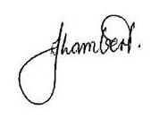
Elizabeth Lambert
Chief Development Planner
Development Assessment and Certification

